2ac “enviro” da

Every 1nc link author is either racist or has direct ties to hate-groups – we’ll footnote the articles so they can educate themselves during prep time. Vote aff on presumption – every claim should be dismissed as an ideological assertion unless they can defend their scholarship.

Reading this disad propagates biological racism and sterilization.
King 13 (Malcom, associate director in DEEWR Labour Market Strategy in Canberra, “Rise of the populationists greenwashes racism,” 8-16, https://www.greenleft.org.au/content/rise-populationists-greenwashes-racism, CMR)
The Australian environmental movement is under attack by populationist and anti-immigration forces in a calculated attempt to divide the Green Party vote at the federal election. The Stable Population Party (SPP), the Stop Population Growth Now (SPGN) Party in South Australia and their mother organisation, Sustainable Population Australia, are “green washing” their anti-immigration policies to make them more palatable to the electorate. In Australia the thin edge of the population control wedge is the SPP. It wants to create a one in/one out immigration system, stop building houses for first home buyers, stop the Kiwis arriving, reduce child support payments and especially parental leave, stop 457 visas and slash international student numbers. In uncertain times such as these, the populationists blame immigrants (and poor African women) for all of the woes of modern society. Between 1960 and 1980 more than 20 million people worldwide were cajoled or forced into having intrauterine device implants, hysterectomies or vasectomies. In the US they were mainly the mentally ill, single mothers and the disabled. By the 1970s, the evangelical fervour of the Third World populationist push of the Ford Foundation, the Rockefeller Trust and former US secretary of defense Robert McNamara, had failed to make a dent in population growth. For all of their scientific studies, propaganda, research and the millions of dollars spent, population control simply did not work. The reason is contraception is only one factor in a web of variables in the life of a woman living in the Third World. It is important but not as important as earning money, providing children with clean drinking water, healthy food and a good education. Population control is far more complex than implanting IUDs, injecting people with the contraceptive Depo Provera or offering them cash to be sterilised. The anti-population literature from the 1960s and 70s is hauntingly familiar to the strident language used by the SPA and its allies here. They turned political problems into biological problems and human history was recast as natural history. The SPP, SPGN and the SPA have been picking at the scab of immigration for some years. Like Pauline Hanson in a koala suit, they cloak reactionary politics in the garb of environmentalism, but — unlike the Greens — they have no environmental credentials. They “green wash” their policies by appealing to environmental values, while promoting the tired idea that Asians, and now Africans, are waiting to invade via immigration. The fear is not mixing races. It’s that these newcomers will destroy flora and fauna while eating us out of house and home. The populationists invoke the concept of lebensraum, as the Nazis did, suggesting that nations are bodies, and that political borders must accommodate biological processes of growth. They are fixated by boundaries, systems and limits to growth. For the SPP and their fellow travellers, trends on fertility, mortality, and migration provide the best measures of degeneration. In the mid 1940s a Princeton demographer, Dudley Kirk, had “nutted” the population problem out. He predicted that the Western pattern of mortality declines and rapid population growth would spread across Asia. There was no alternative but to assist development in order to reduce birth rates. While miracle cures and herbicides might rapidly cut mortality, Kirk said fertility would not begin to fall until peasants moved to cities, earned paycheques and enrolled their children in school. This is exactly what is happening now in large Asian cities — except no one told the urban planners. He also correctly predicted that the “Asiatic peoples” would become westernised and that population growth would slow. He was correct. In some European nations and Japan it is now going backwards. By the end of World War Two, the stage was set for the populationist seed to burst into flower and promote the cause to foreign governments in India, Ceylon, Africa and Asia. The critical flaw was a lack of post-procedural care. Infection was rife. Women after childbirth were vulnerable and easy targets for those pushing sterilisation. But the real problem — shared by their contemporary Australian colleagues — was the objectification of the people they were trying to help. They were seen as statistics rather than living, feeling human beings. One well-known example of what went wrong with “global family planning” is the Dalkon Shield IUD made by AH Robins corporation. It featured rows of prongs that made it resistant to expulsions but also made it painful to insert or remove. Its fatal flaw was a multifilament “tail” that provided a path for infection. By the time women flooded hospitals in America with life-threatening complications in the early 1970s, the manufacturer had offered Dalkon Shields in bulk and unsterilised to USAID at a discount price. About 440,000 women in 42 countries used them by the time the recall order was issued in 1975. Many women in the Third World — who had no local doctor or none they could afford — died of septicemia. This was a tragedy of unimaginable proportions. Another dramatic example was the mobile vasectomy camp, which appeared in the Indian state of Maharashtra. During a five-week intensive family planning campaign in 1960, almost 15,000 people were sterilised. In 1962, 158,000 Indians went under the knife as the Ministry of Health encouraged the use of mobile units to sterilise people institutionalised for tuberculosis, leprosy or mental illness. The genesis of the populationist environment movement really started with the publication of books in 1948, Fairfield Osborn’s Plundered Planet and William Vogt’s Road to Survival. Vogt favoured sterilisation bonuses to be paid to the shiftless. Vogt’s chief concerns — cheaper contraceptives, education and linking food aid to population control — helped set an agenda that would persist for 30 years. He showed that even though everyone shared the same “road to survival”, of course those that survived would be white, male and from the West. Today we also see networks and communities of common interest in the SPP, SPA and SPGN, John Tanton and the Social Contract Press, the Federation for American Immigration Reform (FAIR), NumbersUSA and Population Matters (UK) who were organised to politically control immigration. They have sought to curry favour with community and environmental groups to “greenwash” their anti-immigration message. Roy Beck, the head of NumbersUSA, visited Australia in January. He did the rounds of the populationist groups and also met Terri and Bindi Irwin on the Sunshine Coast. Recently Bindi publicly said population growth in Africa needed to be cut and girls as young as 15 should implanted with IUDs. Beck is one of the leaders of the immigration restrictionists in America and the master “greenwasher”. His job is to convince environmentalists that they too must oppose immigration if they are to save the environment. The SPP, SPGN and Population Matters (UK) say that women in Africa are to blame, yet they also blame the Australian government for allowing so many immigrants and refugees into Australia. These black women are guilty in Africa and when they immigrate to Australia, they are guilty here too. The SPP and the SPGN want it both ways: the power to repel immigrants from our shores while hounding them in their homelands. The birth rate in Mali is 6.29 births per woman. In the US it is 2.1. So, if the problem is population, then Mali is where they should start. But the average person in Mali is responsible for 0.06 tonnes of CO2 per year while the average person in the US is responsible for 17 tonnes. So, the average person in the US is responsible for about 283 times more carbon emissions than the average person in Mali. In this context, complaining about another Malian baby seems foolish. The populationists say that if we aspire to a world where Malians have a better quality of life than they do now, then they will each use more resources and this will only be possible with a lower population. They are wrong. It is possible for a society to live well and use less of the world’s finite resources, although to do that would require an end to the constant growth that capitalism requires. Their certainty that population correlates to consumption comes from the belief that we should learn from ecology — too many rabbits in a garden can eat all of the flowers and then have none left. Each new rabbit means an equal increase in the rate of consumption of flowers. But humans are different. We are the only species with such vast inequality. Talking about population serves to shift blame from the rich in the West onto those who are least to blame. The SPP and SPGN have done nothing to reduce Australian consumption rates, restrict mining industries or hold polluters accountable. Yet they’re working overtime to convince environmentalists and community groups to do their dirty work by blaming immigrants for environmental degradation. It is the emancipation of women, not population control, that has enabled feminists and environmentalists to forge a new consensus to promote empowerment, not control. If the horrors of the Third World population control push of yesteryear are not evidence enough of perpetuating a reckless invasion on the reproductive health of the poorest of the poor, what does it say about the regressive and manipulative tactics of Australian populationists who want us to walk down that path again?

This isn’t an abstraction or hypothetical – claims of ‘fertility’ by immigrants and other groups have been used across US history to promote racial purity and eugenics.
PBS 16 (“UNWANTED STERILIZATION AND EUGENICS PROGRAMS IN THE UNITED STATES,” 1-29, http://www.pbs.org/independentlens/blog/unwanted-sterilization-and-eugenics-programs-in-the-united-states/, CMR)
Coerced sterilization is a shameful part of America’s history, and one doesn’t have to go too far back to find examples of it. Used as a means of controlling “undesirable” populations – immigrants, people of color, poor people, unmarried mothers, the disabled, the mentally ill – federally-funded sterilization programs took place in 32 states throughout the 20th century. Driven by prejudiced notions of science and social control, these programs informed policies on immigration and segregation. As historian William Deverell explains in a piece discussing the “Asexualization Acts” that led to the sterilization of more than 20,000 California men and women,“If you are sterilizing someone, you are saying, if not to them directly, ‘Your possible progeny are inassimilable, and we choose not to deal with that.’” According to Andrea Estrada at UC Santa Barbara, forced sterilization was particularly rampant in California (the state’s eugenics program even inspired the Nazis): Beginning in 1909 and continuing for 70 years, California led the country in the number of sterilization procedures performed on men and women, often without their full knowledge and consent. Approximately 20,000 sterilizations took place in state institutions, comprising one-third of the total number performed in the 32 states where such action was legal. (from The UC Santa Barbara Current) — “There is today one state,” wrote Hitler, “in which at least weak beginnings toward a better conception [of citizenship] are noticeable. Of course, it is not our model German Republic, but the United States.” (from The L.A. Times) Researcher Alex Stern, author of the new book Eugenic Nation: Faults and Frontiers of Better Breeding in America, adds: “In the early 20th century across the country, medical superintendents, legislators, and social reformers affiliated with an emerging eugenics movement joined forces to put sterilization laws on the books. Such legislation was motivated by crude theories of human heredity that posited the wholesale inheritance of traits associated with a panoply of feared conditions such as criminality, feeblemindedness, and sexual deviance. Many sterilization advocates viewed reproductive surgery as a necessary public health intervention that would protect society from deleterious genes and the social and economic costs of managing ‘degenerate stock’.” Eugenics was a commonly accepted means of protecting society from the offspring (and therefore equally suspect) of those individuals deemed inferior or dangerous – the poor, the disabled, the mentally ill, criminals, and people of color.
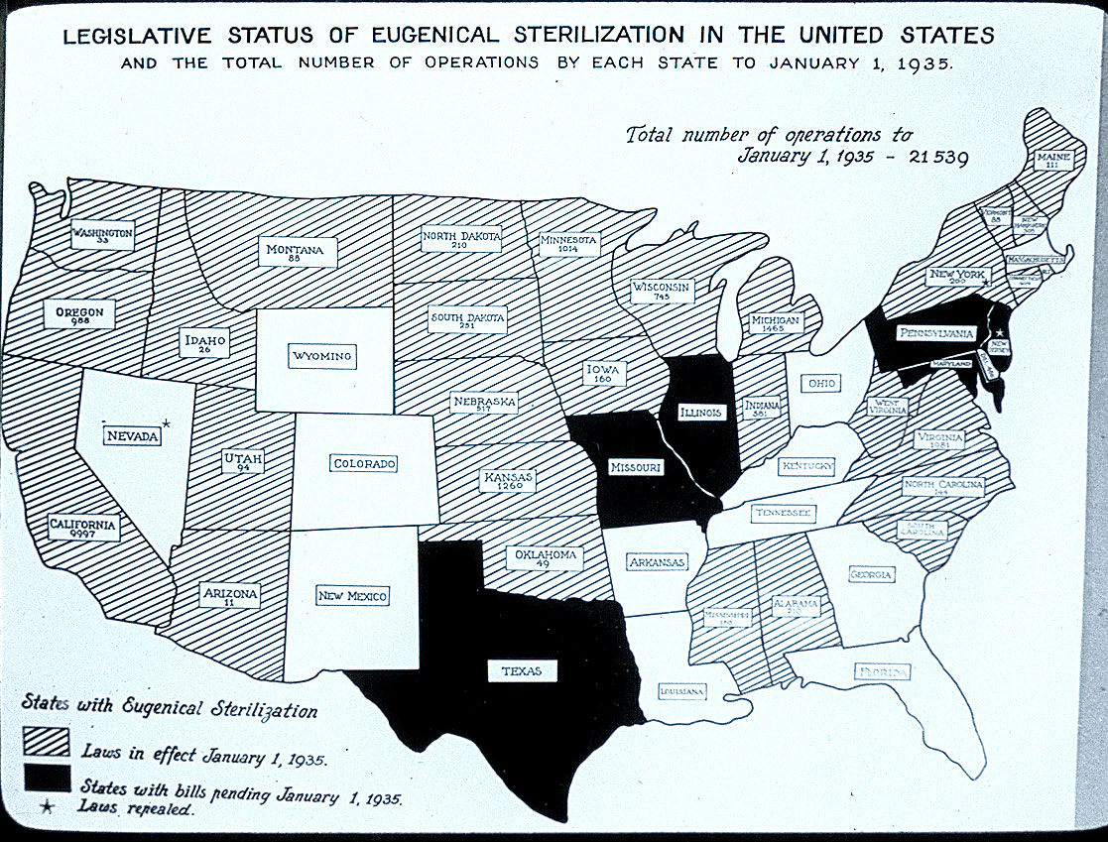
More recently, California prisons are said to have authorized sterilizations of nearly 150 female inmates between 2006 and 2010. This article from the Center for Investigative reporting reveals how the state paid doctors $147,460 to perform tubal ligations that former inmates say were done under coercion. But California is far from being the only state with such troubled practices. For a disturbing history lesson, check out this comprehensive database for your state’s eugenics history. You can find out more information on state-by-state sterilization policies, the number of victims, institutions where sterilizations were performed, and leading opponents and proponents. While California’s eugenics programs were driven in part by anti-Asian and anti-Mexican prejudice, Southern states also employed sterilization as a means of controlling African American populations. “Mississippi appendectomies” was another name for unnecessary hysterectomies performed at teaching hospitals in the South on women of color as practice for medical students. This NBC news article discusses North Carolina’s eugenics program, including stories from victims of forced sterilization like Elaine Riddick. A third of the sterilizations were done on girls under 18, even as young as 9. The state also targeted individuals seen as “delinquent” or “unwholesome.” For a closer look, see Belle Bogg’s “For the Public Good,” with original video by Olympia Stone that features Willis Lynch, who was sterilized at the age of 14 while living in a North Carolina juvenile detention facility. Gregory W. Rutecki, MD writes about the forced sterilization of Native Americans, which persisted into the 1970s and 1980s, with examples of young women receiving tubal ligations when they were getting appendectomies. It’s estimated that as many as 25-50 percent of Native American women were sterilized between 1970 and 1976. Forced sterilization programs are also a part of history in Puerto Rico, where sterilization rates are said to be the highest in the world. Landmark Cases The film No Más Bebés follows the story of Mexican American women who were sterilized under duress while giving birth at Los Angeles County-USC Medical Center in the 1960s and 1970s. Madrigal v. Quilligan, the case portrayed in the film, is one of several landmark cases that’s affected the reproductive rights of underserved populations, for better or for worse. Here are some other important cases: Buck v. Bell: In 1927, Carrie Buck, a poor white woman, was the first person to be sterilized in Virginia under a new law. Carrie’s mother had been involuntarily institutionalized for being “feebleminded” and “promiscuous.” Carrie was assumed to have inherited these traits, and was sterilized after giving birth. This Supreme Court case led to the sterilization of 65,000 Americans with mental illness or developmental disabilities from the 1920s to the ’70s. (Justice Oliver Wendell Holmes wrote in reference to Carrie: “Three generations of imbeciles are enough.”) The court ruling still stands today. [Note: This story was also the subject of a 1994 made-for-TV movie starring Marlee Matlin.] From the documentary Fixed to Fail: Buck vs. Bell: Relf v. Weinberger: Mary Alice and Minnie Relf, poor African American sisters from Alabama, were sterilized at the ages of 14 and 12. Their mother, who was illiterate, had signed an “X” on a piece of paper she believed gave permission for her daughters, who were both mentally disabled, to receive birth control shots. In 1974, the Southern Poverty Law Center filed a lawsuit on behalf of the Relf sisters, revealing that 100,000 to 150,000 poor people were being sterilized each year under federally-funded programs. Eugenics Compensation Act: In December 2015, the US Senate voted unanimously to help surviving victims of forced sterilization. North Carolina has paid $35,000 to 220 surviving victims of its eugenics program. Virginia agreed to give surviving victims $25,000 each. While the case in No Más Bebés occurred forty years ago, issues of reproductive justice are still relevant today, as state laws continue to restrict access to abortion and birth control. Deborah Reid of the National Health Law program writes: “The concept of reproductive justice, which is firmly rooted in a human rights framework that supports the ability of all women to make and direct their own reproductive decisions. These decisions could include obtaining contraception, abortion, sterilization, and/or maternity care. Accompanying that right is the obligation of the government and larger society to create laws, policies, and systems conducive to supporting those decisions.” For organizations such as the National Latina Institute for Reproductive Health, reproductive justice involves not only access to affordable birth control, abortion, and health care, but also providing access to women who are being held in immigration detention centers. It’s work that connects the dots between power inequities and bodily self-determination – something the eugenics movement sought to limit. As No Más Bebés director Renee Tajima-Peña says in an interview with Colorlines: “The reproductive justice framework is to make sure that people listen to the needs and the voices of poor women, women of color and immigrant women who’ve been marginalized.”

The impact is internalized hatred by migrant and non-white debaters – this is a voting issue that operates above the game.
David, PhD, 15 (E. J. R. David Ph.D., “Internalized Oppression: We Need to Stop Hating Ourselves,” https://www.psychologytoday.com/us/blog/unseen-and-unheard/201509/internalized-oppression-we-need-stop-hating-ourselves, CMR)
Although the attitudes and behaviors described above seem very wide-ranging, all of them actually have one common root: Internalized Oppression. Oppression can come in many forms, and we can be oppressed for various reasons – because of our race, culture, sexual orientation, gender, and others. When we accept or “buy-in to” the negative and inferiorizing messages that are propagated about who we are, then we have begun to internalize the oppression that we experienced. We have come to learn that—having certain traits, being a member of a particular group, and being who we are—are not good enough or are not desirable. Sometimes, we even learn to hate our traits, our groups, ourselves. Even further, sometimes we end up hurting ourselves, our communities, and those who we share many similarities with, the ones who likely care for us the most—our family and friends. This is why internalized oppression does not just affect a few individuals. Instead, internalized oppression can destroy families, cultures, and communities. We also need to realize that the inferiorizing and dehumanizing messages about women, racial minorities, LGBT folks, people with disabilities, and other marginalized groups that we propagate and allow to survive in our society also affect people's mental health. Such messages distort their views of themselves and others. Distortion of reality can lead to harmful emotions (e.g., hate) toward one's self and others. Such distortions can lead to harmful, sometimes deadly, behaviors—both toward one's self (e.g., suicide) and toward others (e.g., abuse of women, hate crimes). Such widespread, serious, heart breaking, and long lasting negative consequences are the reasons why I felt that a book is needed to show us that internalized oppression has already been damaging our communities for many generations, and that it continues to do so. The Book on the Psychology of Internalized Oppression And that's when the work on my most recent book—Internalized Oppression: The Psychology of Marginalized Groups—began. I was very excited at the start to get to work and read the manuscripts from the contributors. Because each chapter includes heartfelt narratives and stories, however, I was quickly reminded that this work was not fun at all. The topic is already depressing enough, but also reading the narratives that express immense losses, sorrows, and pains gave me regular sensations of a knife piercing through my heart. Springer Publishing Company Source: Springer Publishing Company As a Filipino American immigrant with a colonized mentality, internalized oppression has always been very real to me. I didn’t know it was possible, but reading the stories from many others who at the surface may seem very different from me, made internalized oppression even “more real.” Perhaps being “more real” means the realization that internalized oppression is more widespread and impactful than I previously thought. Whatever it means, I know that—despite the darkness and the bleakness—I came out of this experience feeling less alone and more inspired, connected, hopeful, and stronger than ever to address internalized oppression and its negative consequences on communities throughout the world. And to this, the book is the first to highlight the universality of internalized oppression, while at the same time acknowledging its unique manifestations and implications for various groups such as African Americans, Latinas/os, Asian Americans, Pacific Islanders, American Indians, Alaska Natives, women, the Lesbian, Gay, Bisexual, and Transgender community, and people with disabilities. The chapters are written by leading and emerging scholars, who share their personal experiences to provide a real-world point of view. Additionally, each chapter is coauthored by a member of the particular community group they are writing about, which helps bring a first-hand, insider perspective on the lived realities of such groups. Even further, the community coauthors' experiences also help to bring academic concepts to life. One of the main goals of this book is to illuminate the widespread existence and destruction of internalized oppression, and hopefully unite various groups around the world to work together toward addressing this most insidious form of oppression. Perhaps by seeing that all of us are affected by the devastation of oppression and internalized oppression, then we will come to realize that we should care. Perhaps we will also see that all of us have a role in oppression. Then, maybe, all of us might do something to address it. It is time for us to become aware of how internalized oppression may exist and operate within us so that we may begin to stop it, control its effects, and cease the possibility that we pass it on to future generations. We’re not born hating ourselves; we learned that. Therefore, we can unlearn it. It’s not easy, but we need to.

The 2nc/1nr will read a pro-dict from politifact – that’s just the CSIS being like “nah, we promise we’re not racists”. Spoiler alert – racists usually don’t out themselves.
Sherman 17 – Amy Sherman, staff writer for PolitiFact, 2017 (“Is the Center for Immigration Studies a hate group, as the Southern Poverty Law Center says?,” PolitiFact, March 22nd, http://www.politifact.com/florida/article/2017/mar/22/center-immigration-studies-hate-group-southern-pov/)
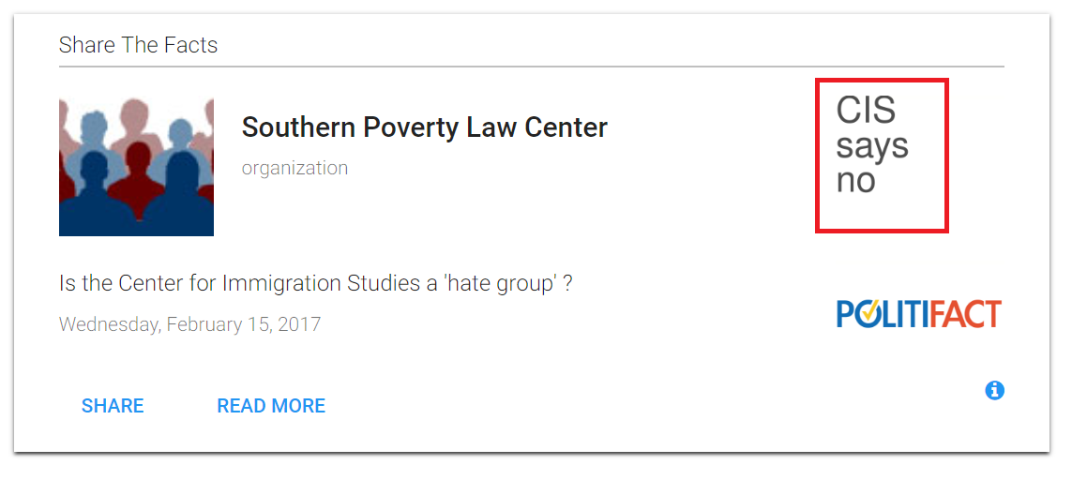

--- at: cis

but seriously, the CIS is a hate group
Beirich 17 (Heidi, Intelligence Project Director, 3-23, https://www.splcenter.org/hatewatch/2017/03/23/hate-groups-center-immigration-studies-want-you-believe-they%E2%80%99re-mainstream, CMR)
In the nearly 30 years since the Southern Poverty Law Center has been monitoring the American radical right we’ve seen a major shift in the nature of organized groups that specialize in vilifying certain people because of their race, ethnicity or other characteristic.
In the beginning, they were the usual suspects: Klan factions, neo-Nazi groups, black separatists, racist skinheads and the like.
We’re in a different world today. Hate has gone mainstream. Today, the purveyors of hate don’t always burn crosses or use racial slurs. They might wear suits and ties. They might have sophisticated public relations operations. They might even testify before Congress.
They’re also more likely to be animated by a nativist or white nationalist ideology that sees the “white race” as being under siege by immigrants of color across the Western world. Reflecting this trend, our annual list of hate groups has evolved to include more groups closely linked to white nationalism.
This year, for the first time, we listed the Center for Immigration Studies (CIS), a nativist think tank that churns out a constant stream of fear-mongering misinformation about Latino immigrants. Predictably, the hate group designation provoked an attack by the group’s executive director, Mark Krikorian, whose March 17 commentary in The Washington Post accused the SPLC of conflating groups like the Klan with groups, like his, that “simply do not share” our political beliefs.
It’s understandable that Krikorian would recoil from being labeled a “hate group.” But the CIS has earned it – and not only because of statements by Krikorian, such as his suggestion after the devastating earthquake in Haiti that the country is “so screwed up because it wasn’t colonized long enough.”
CIS is the brainchild of John Tanton, the father of the modern nativist movement, and part of a network of closely related anti-immigrant groups that Tanton founded. These groups have been responsible for much of the hysteria about immigrants that dominates conservative politics.
Tanton, a retired Michigan ophthalmologist, spent decades at the heart of the white nationalist movement. In addition to his flagship organization, the Federation for American Immigration Reform (FAIR), he founded and operated the Social Contract Press, which has published numerous overtly racist tracts, including the rancid novel Camp of the Saints.
Tanton’s worldview can be summed up in a letter he wrote to a friend in 1993: “I’ve come to the point of view that for European-American society and culture to persist requires a European-American majority, and a clear one at that.” It was a New York Times expose of Tanton’s history of working with racists and Holocaust deniers that finally forced him off the board of FAIR in 2011.
Krikorian doesn’t defend Tanton’s views but dismisses his involvement with CIS as “irrelevant.” But the fact is, CIS and FAIR are branches of the same family tree.
In a 1985 memo, Tanton describes establishing CIS as a project of FAIR, and the two groups shared board members for years.
But the association with Tanton was not enough to earn the hate group label. There’s more.
In recent years, CIS has routinely disseminated the works of white nationalist writers, including Jared Taylor of American Renaissance. Taylor has written that “[w]hen blacks are left entirely to their own devices, Western civilization – any kind of civilization – disappears.”
In January, CIS promoted an article by Kevin MacDonald, the anti-Semitic editor of the journal Occidental Quarterly, that first appeared on VDARE, a website run by white nationalist Peter Brimelow and named for Virginia Dare, supposedly the first white child born in the New World. In the article, MacDonald asks why “Jewish organizations” are promoting “the refugee invasion of Europe.”
In the past year, CIS also has circulated six articles from VDARE by John Derbyshire, who was fired from the conservative National Review after writing a racist essay.
In June 2016, CIS distributed an article from John Friend, a contributing editor of the anti-Semitic The Barnes Review, claiming that “so-called refugees are committing rape and other horrific crimes against European women and men in increasing numbers.” Friend once described the Holocaust as a “manufactured narrative, chock full of a wide variety of ridiculous claims and impossible events, all to advance the Jewish agenda of world domination and subjugation.”
Krikorian incredulously suggests that CIS’ promotion of white nationalists was merely an accident – that the group’s newsletters “occasionally included pieces by writers who turned out to be cranks.”
He does, however, defend the work of Jason Richwine, who now blogs and writes reports for CIS. Richwine resigned from the conservative Heritage Foundation after his Harvard dissertation asserting that Latino immigrants are less intelligent than “native whites” came to light. Richwine has also been a contributor to white nationalist leader Richard Spencer’s website Alternative Right.
Krikorian argues that our hate group list is intended to shut down debate about issues such as immigration. Again, not true. Our purpose is to help the public understand just who’s doing the talking.

--- at: cafaro / kolankiewicz / pfir

Cafaro, Kolankiewicz, and PFIR are racist propaganda from their white nationalist founder – John Taton
Angus 12 (Ian, “Racism in a fancy green wrapper,” http://climateandcapitalism.com/2012/08/27/racism-green-wrapper/)
I was recently invited to speak in Washington in October, at a public meeting organized by Progressives for Immigration Reform (PFIR). PFIR president Philip Cafaro told me the planned event would be part of “a new project, an ‘Environmental Impact Statement on US Immigration Policy,’ to look into the impacts or lack thereof of immigration and population growth on the US environment.” He proposed a four-person panel featuring himself and and his colleague Leon Kolankiewicz, challenged by “two skeptics,” one of whom would be me. PFIR would pay my travel expenses, plus an honorarium. I declined Cafaro’s invitation. There is no possibility that a project organized by PFIR would consider immigration and the environment objectively — and there is no possibility that I would speak at any PFIR meeting, let alone one designed to give their latest project the illusion of balance. PFIR is described by the Southern Poverty Law Center as a group that “purports to represent liberals who believe immigration must be radically curtailed in order to preserve the American environment … the latest attempt by nativist forces to appear as something they are not.” What they really represent, as my good friends at the Global Environmental Justice Project say, is “just plain old racism in a fancy green wrapper.” The radical immigration activists at Imagine 2050 agree: “Progressives for Immigration Reform (PFIR), a front group that is part of white nationalist John Tanton’s network of anti-immigrant groups, is grossly misnamed and far from progressive. Even the slightest tie to Tanton’s anti-immigrant network erases an organization’s ‘progressive’ credibility, and PFIR is a staunch Tanton-network mouthpiece. “As such, it fills a very specific niche within the architecture of the anti-immigrant movement. PFIR exists, as its name suggests, to try and make the Tanton Network’s racist, anti-immigrant agenda palatable to moderates and liberals, often by describing environmental degradation and immigration in the same breath.” PFIR has now launched a website for its new project, promising “a thorough, objective analysis of the ecological impacts of U.S. immigration policy.” They’ve posted a list of articles and books as resources — most of them toe the populationist line, but for window-dressing they’ve included a handful of critical works, including Too Many People?, which I co-wrote with Simon Butler, and The Greening of Hate, by Betsy Hartmann. Nicole Loeffler-Gladstone of Imagine 2050 writes: “Rather than present a new message, PFIR’s latest project attempts to disguise the same old rhetoric under a banner of objectivity. Their ‘United States Immigration Policy EIS’ lists a variety of resources, with articles by Tanton Network stalwarts like Roy Beck and Philip Cafaro (not to mention their contemporaries, including eugenics supporter Garrett Hardin and populationist Paul Ehrlich) listed alongside ecosocialist Ian Angus, the Population and Development Program at Hampshire College, and your very own Center for New Community. “Unfortunately for PFIR, this desperate flail for credibility will not be accomplished by simply tossing a few names around. A PFIR-run, Tanton-backed examination of immigration policies will always result in the same vile conclusion no matter how the study itself is presented: white supremacists in the United States are threatened by the presence of immigrants. “They will continue to try and lure unsuspecting environmentalists and politically progressive folks into their camp, but PFIR’s role within the anti-immigrant community is firmly cemented and well known. It is up to real environmentalists, those who reject the scapegoating of immigrants and the influence of bigotry, to continue to expose them.” Amen

Who is John Tanton? I’m glad you asked – speaking for himself.
SPLC No date (“About John Tanton,” https://www.splcenter.org/fighting-hate/extremist-files/individual/john-tanton)
A retired Michigan ophthalmologist, Tanton has white nationalist beliefs and has written that to maintain American culture, "a European-American majority" is required. As of 2010, Tanton served on FAIR’s board of directors.
In His Own Words
"I've come to the point of view that for European-American society and culture to persist requires a European-American majority, and a clear one at that."
– Dec. 10, 1993, letter to the late Garrett Hardin, a controversial ecology professor.
"I have no doubt that individual minority persons can assimilate to the culture necessary to run an advanced society but if through mass migration, the culture of the homeland is transplanted from Latin America to California, then my guess is we will see the same degree of success with governmental and social institutions that we have seen in Latin America."
– Jan. 26, 1996, letter to Roy Beck, executive director of NumbersUSA (and then an employee of Tanton's foundation U.S. Inc.).
"Do we leave it to individuals to decide that they are the intelligent ones who should have more kids? And more troublesome, what about the less intelligent, who logically should have less? Who is going to break the bad news [to less intelligent individuals], and how will it be implemented?"
– Sept. 18, 1996, letter to now-deceased California multimillionaire and eugenicist Robert K. Graham.
"I write to encourage keeping track of those on our same side of the issue, but who are nonetheless our competitors for dollars and members."
– April 20, 1998, correspondence asking several FAIR employees to ensure they receive mailings from American Renaissance, a racist, pseudo-scientific magazine focusing on race, intelligence and eugenics. (The underlining was in Tanton's original letter).

No favorite ice cream flavor listed but I’d guess “white”

--- at: rubenstein

Rubenstein propagates white nationalism and biological racism – peep this articles he’s written:
Glasstetter 12 (Josh, “Second White Nationalist Writing for Dow Jones’ MarketWatch,” 4-13, http://www.rightwingwatch.org/post/second-white-nationalist-writing-for-dow-jones-marketwatch/, CMR)
Brimelow is already rallying to the defense of Derbyshire and Weissberg, but with any luck he’ll be able to land them jobs at MarketWatch like he did another of his white nationalist collaborators – Edwin Rubenstein. Rubenstein, an economic consultant, is a frequent contributor to MarketWatch and VDARE. He also provides research and analysis for the National Policy Institute, which was founded in 2005 to “elevate the consciousness of whites, ensure our biological and cultural continuity, and protect our civil rights.” Here’s NPI’s “about” page:
Rubenstein’s writing at VDARE seems to focus on three themes:
Americans (i.e. European whites) are on the verge of losing their country if they don’t take drastic steps to stop immigration
Education and affirmative action won’t help blacks and Hispanics because they can’t, or won’t, improve and assimilate
Not only are blue collar whites getting crushed by immigration, but so are white professionals, including doctors and PHDs in the sciences
This partial archive of Rubenstein’s writing for MarketWatch, which he does in conjunction with Brimelow, shows that he’s been working for them since 2003. That’s also when he began writing for VDARE.
MarketWatch, part of News Corporation’s Dow Jones division, has thus far refused to comment on why they employ a disgraced white nationalist leader who was fired back in 1998 from the right-wing National Review over his racist views and writing. Now it turns out that they employ not one – but two – prominent white nationalists. They have some explaining to do.
I’ve collected some of Rubenstein’s greatest hits on VDARE. Since the entire site has been temporarily given over to a fundraising appeal by Brimelow, I’ll instead link to Google cache versions of the articles:
Diversity Is Strength. It’s Also Car Theft.
Immigration Moratorium Could Save Historic American Majority
Whites Lose Ground to Blacks, Hispanics—Americans Lose Ground To Everyone
Legal Immigration—The Bigger Problem
“Everyone is against illegal immigration (they say). Problem: legal immigration is actually the bigger problem.”
Bad News About Those South Asian Model Immigrants
“Most of this cohort end up with dead end jobs—running cheap motels, small neighborhood stores, marginal gas stations, or taxi-driving.”
Affirmative Action, Immigration, Curing America Of White Doctors
“At the end of the day, not just affirmative action but also immigration policy is on the way to curing America of white doctors.”
Hispanic Immigrants are Dangerous To Workplace Safety
“Over the years, billions have been spent teaching English to Hispanic immigrants. Yet, as we point out in an earlier article, the share of Hispanic immigrants that is “linguistically isolated,” i.e., speak English poorly or not at all, is increasing. Even simple English language instructions are incomprehensible to the “linguistically isolated.”
Children, Grandchildren Of Mexican Immigrants Fail To Close The Education Gap
U.S PhDs Have It Tough Enough Without Importing Immigrants
“Move over computer programmers. Medical doctors are also alleged to be in ‘short supply’ these days. Meaning that we must import them from abroad—right? Wrong.”
Immigrant Doctors Aren’t Necessary Either
Hispanic Family Values?
The Next Big Headline: Most Births Minority in 2011.
Cuban Immigration and the Myth of Miami
“Even immigration skeptics rarely challenge the role of Cuban immigrants in reviving Miami’s economic fortunes.”
Why More Immigrant Science, Technology, Engineering, Math Graduates When So Many American STEM Graduates Are Unemployed?

--- slpc pro-dict

You can trust the SLPC – they are “left-of-center” but engage in fact-based reporting
https://mediabiasfactcheck.com/southern-poverty-law-center/

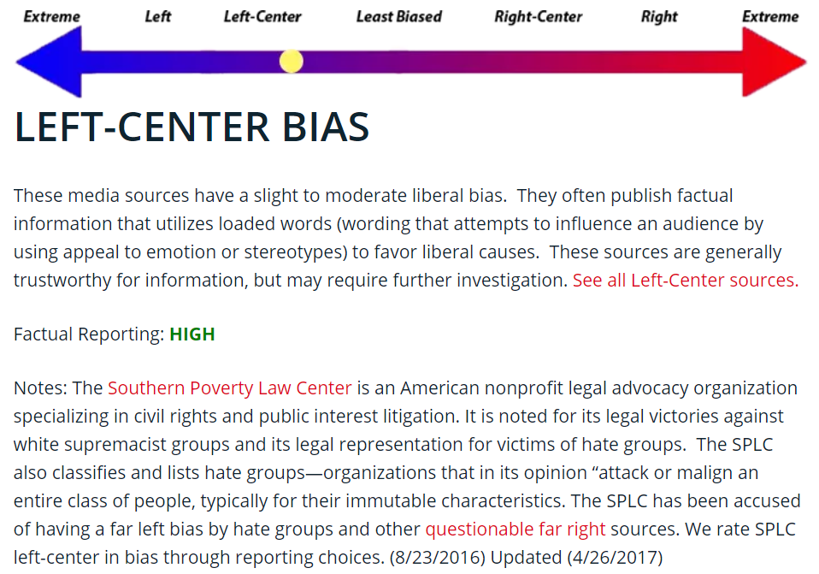

--- additional evidence

Their argument is nothing more than “greenwashing” been engineered by racists and white nativists to scapegoat immigrants for environmental problems
SLPC 10 (Southern Poverty Law Center, “Greenwash: Nativists, Environmentalism and the Hypocrisy of Hate,” June 30, https://www.splcenter.org/20100630/greenwash-nativists-environmentalism-and-hypocrisy-hate, CMR)
A quarter of a century ago, John Tanton, a white nationalist who would go on to almost single-handedly construct the contemporary, hard-line anti-immigration movement, wrote about his secret desire to bring the Sierra Club, the nation's largest environmental organization, into the nativist fold. He spelled out his motive clearly: Using an organization perceived by the public as part of the liberal left would insulate nativists from charges of racism — charges that, given the explicitly pro-"European-American" advocacy of Tanton and many of his allies over the years, would likely otherwise stick. In the ensuing decades, nativist forces followed Tanton's script, making several attempts to win over the Sierra Club and its hundreds of thousands of members. That effort culminated in 2004, when nativists mounted a serious effort to take over the Sierra Club's board of directors, an attempt that was beaten back only after a strenuous campaign by Sierra Club members and groups including the Southern Poverty Law Center. The attempt was a classic case of "greenwashing" — a cynical effort by nativist activists to seduce environmentalists to join their cause for purely strategic reasons. Now, the greenwashers are back. In the last few years, right-wing groups have paid to run expensive advertisements in liberal publications that explicitly call on environmentalists and other "progressives" to join their anti-immigration cause. They've created an organization called Progressives for Immigration Reform that purports to represent liberals who believe immigration must be radically curtailed in order to preserve the American environment. They've constructed websites accusing immigrants of being responsible for urban sprawl, traffic congestion, overconsumption and a host of other environmental evils. Time and again, they have suggested that immigration is the most important issue for conservationists. The hypocrisy of these come-ons can be astounding. The group headed by Roy Beck, one of the key activists leading the efforts, has given close to half a million dollars to a far-right news service that has described global warming as a hoax. Tanton's wife, who works hand in glove with her husband, runs an anti-immigration political action committee (PAC) that funds candidates with abysmal environmental voting records. The congressional allies of John Tanton, Beck and the other greenwashers are organized into an anti-immigration caucus whose members have even worse environmental voting records than the beneficiaries of Mary Lou Tanton's PAC. John Tanton's U.S. Inc., a foundation set up to fund nativist groups, spent about $150,000 on a highly conservative fundraising agency whose client list includes several major anti-environmental organizations. This new wave of greenwashing attempts, in particular the formation of Progressives for Immigration Reform as a purported group of “liberals,” is only the latest attempt by nativist forces to appear as something they are not. The white-dominated Federation for American Immigration Reform (FAIR), the most important of the groups founded by Tanton, has been behind the creation of three other front groups that supposedly represented African Americans (Choose Black America), Latino Americans (You Don’t Speak for Me!) and labor (Coalition for the Future American Worker). In fact, FAIR had its own white spokesman double as a press representative for the first two organizations. Another group unrelated to FAIR, Vietnamese for Fair Immigration, turned out to be led by a white man who used a fake Vietnamese surname and whose only connection to that country was that he liked the food. The arguments being made by the nativists today — in a nutshell, that immigration drives population increase and that a growing population is the main driver of environmental degradation — have in the last 15 years been rejected by the mainstream of the environmental movement as far too simplistic. The allegation that immigrants are responsible for urban sprawl, for example, ignores the fact that most immigrants live in dense, urban neighborhoods and do not contribute significantly to suburban or exurban sprawl. In a similar way, most conservationists have come to believe that many of the world's most intractable environmental problems, including global warming, can only be solved by dealing with them on a worldwide, not a nation-by-nation, basis. The greenwashers are wolves in sheep's clothing, right-wing nativists who are doing their best to seduce the mainstream environmental movement in a bid for legitimacy and more followers. John Tanton, the man who originally devised the strategy, is in fact far more concerned with the impact of Latino and other non-white immigration on a "European-American" culture than on conservation. Most of the greenwashers are men and women of the far right, hardly "progressives." Environmentalists need to be aware of so-called "progressives for immigration reform" and their true motives. These individuals and organizations do not see protecting the environment as their primary goal — on the contrary, the nativists are first and foremost about radically restricting immigration. Environmentalists should not fall for their rhetoric.

